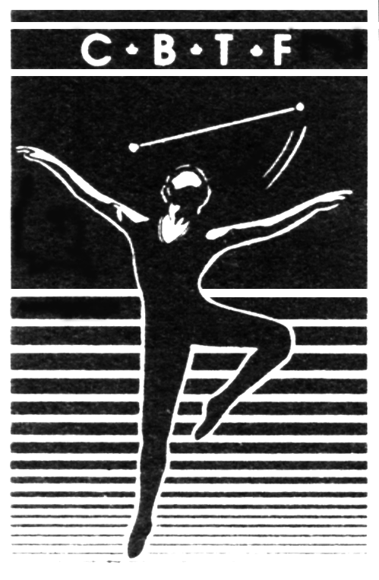
Canadian Baton Twirling Federation

La Fédération Canadienne de Baton Sportif

As a member of the CBTF World Championship Contingent, you are an ambassador for Baton Twirling in Canada and of the CBTF. This privilege is accompanied by certain expectations and responsibilities, as outlined below.

- Exemplary behavior, good sportsmanship and positive attitudes must be displayed at all times.
- Absolutely no use of banned substances (as outlined by WADA) will be tolerated throughout the year leading up to the World Championships. Athletes are prohibited from smoking or the use of alcohol.
- The CBTF and WBTF both adhere to the IOC Anti-Doping Code. Athletes and Judges may be selected for anti-doping testing while at the World Championships. It is the responsibility of each contingent member to be familiar with the Anti-Doping Code and to ensure they are not in violation.
- Athletes are required to remain in the competition facility unless prior permission has granted by their Coach and the Team Manager. Remaining at the competition facility will ensure that all competing athletes will have the full support of the rest of the Canadian Contingent.
- Curfew – Athletes must be in their rooms by 10:00 pm, or earlier as specified by your coach, until all competition days have been completed.
- When requested, all Canadian team members must follow the Dress Code as established by the Team Manager, including wearing the Canadian Team Tracksuit in good condition. Sleeves and pant hems are not to be rolled up and no decals, badges or other personal touches are to be affixed to the tracksuit except those specified by CBTF.
- There will be a Contingent Itinerary to which members are expected to adhere. All Contingent members are expected to attend all team meetings. Daily schedules and other information will be relayed daily via a Contingent Notice Board.

Any violation of team rules will be brought to the attention of the coach, the Team Manager and the CBTF President. At that time, the appropriate course of action will be determined. A serious breach will result in the termination of the offender’s participation in the World Championship competition.

Initials
CBTF Waiver – Participant’s Assumption of Risk: I am aware & understand that there are a number of inherent risks, including a risk of contracting COVID-19, involved in my participation in this sporting activity which are beyond the control of the Canadian Baton Twirling Federation (CBTF), the World Baton Twirling Federation (WBTF) and Competition Officials. I further agree that I assume personal responsibility for any costs as well as any loss, damage, injury or ambulance service resulting from or in connection with such participation at the WBTF World Championships, July 28 - August 8, 2022, at any events organized by the CBTF in conjunction with the WBTF World Championships, as well as during any travel to or from the competition. I have read and understand the Waiver.

Initials
I do hereby declare that I will accompany the Canadian Contingent to the WBTF World Championships for the purpose of competing in the WBTF World Championships and representing Canada and the Canadian Baton Twirling Federation (CBTF). Furthermore, I will abide by all of the rules, regulations and procedures set forth by the CBTF and the World Baton Twirling Federation (WBTF) and agents thereof.

Name and Signature of Contingent Member: |  | Name and Signature of Parent/Guardian,  if Contingent Member is under 18 years:
Print Name |  | Print Name
Signature |  | Signature
Date |  | Date

