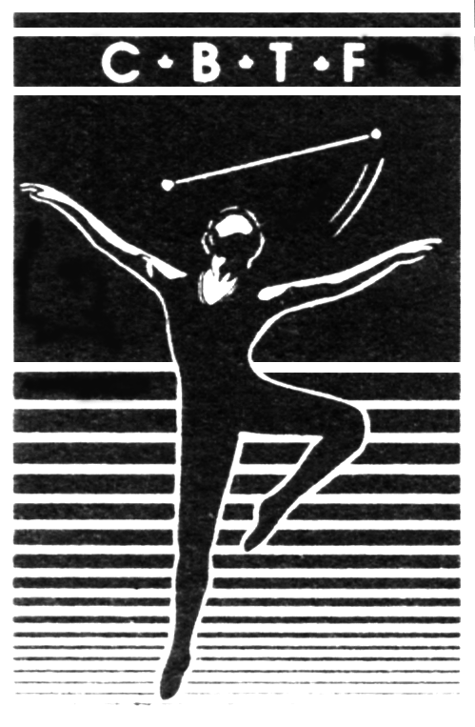
Canadian Baton Twirling Federation

La Fédération Canadienne de Baton Sportif

This checklist is to be used to ensure that we have all pertinent information required in order to be able to enter all members of our contingent on time with WBTF requirements.

Name:_____________________________________________________________________________

I am an: athlete coach judge official spectator (circle applicable one)

For athletes:

I have a CBTF World Team Track suit: yes no (circle applicable one)

I need a name crest for my Track suit jacket: yes no (circle applicable one)

If yes, name to be placed on crest is:_________________________________________ (no nicknames permitted; however, abbreviated names are allowed i.e. Christina may use Chris, etc. )

There will be a tracksuit fitting on May 23, 2022 at the contingent meeting. There will also be a fitting for team practice wear. Black jazz shoes, dance shoes, or running shoes are required for the opening ceremonies and at other times where uniform dress is required.

Have you competed as a member of the Canadian Contingent at any WBTF events (International Cup or World Championships) before? yes no (circle applicable one)

If yes, please list the year, location, and event for each: __________________________________________________________________________________________________________________________________________________________________________________________________________________________________________________________________________________________________________________________________________________________________________________________________________________________________________________________________

I have attached to this checklist the following completed forms (as applicable):

1. Athlete Information Sheet
2. Secret Pal Sheet
3. CBTF Code of Conduct
4. Paper copy of Canadian passport photo page showing valid passport 6 months past the last date of competition
5. Paper copy of your COVID vaccination record
6. Traveler Worksheet (initial payment will be collected during the Team Trials weekend)

Parents/spectators do not need to submit passport pages. All athletes, coaches, judges, and officials must prove their Canadian citizenship. If you are not a Canadian citizen please contact Joanne Moser to discuss whether or not you are eligible to compete for Canada.

The following online forms must be completed immediately following Team Trials (as applicable): Media Consent, WBTF Liability Waiver, Athlete's Consent & Ethics Form, Adjudicator's Consent & Ethics Form. WBTF Athlete Forms (jotform.com); WBTF Adjudicator Forms (jotform.com)

If you have any questions about these forms, please email the Contingent Coordinator at office@cbtf.ca.

